1. Solving problems using array functions on rest countries data.
   1. Get all the countries from Asia continent /region using Filter function

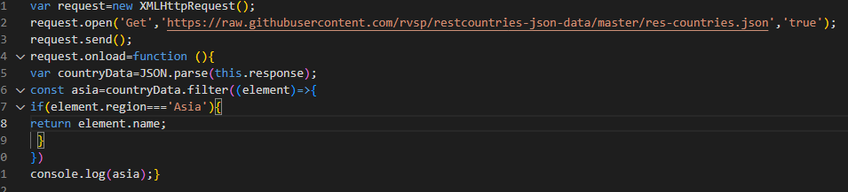

* 1. Get all the countries with a population of less than 2 lakhs using Filter function

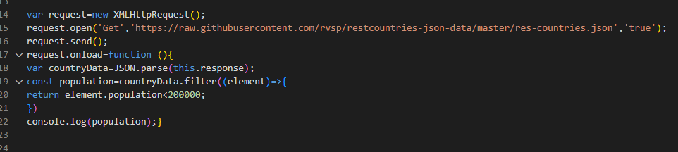

* 1. Print the following details name, capital, flag using forEach function

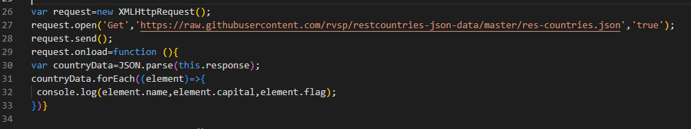

* 1. Print the total population of countries using reduce function

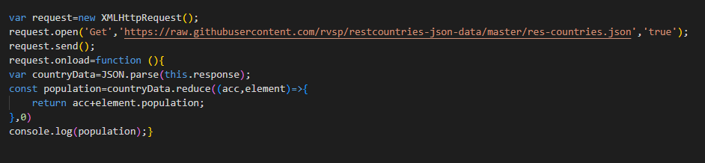

* 1. Print the country which uses US Dollars as currency.

